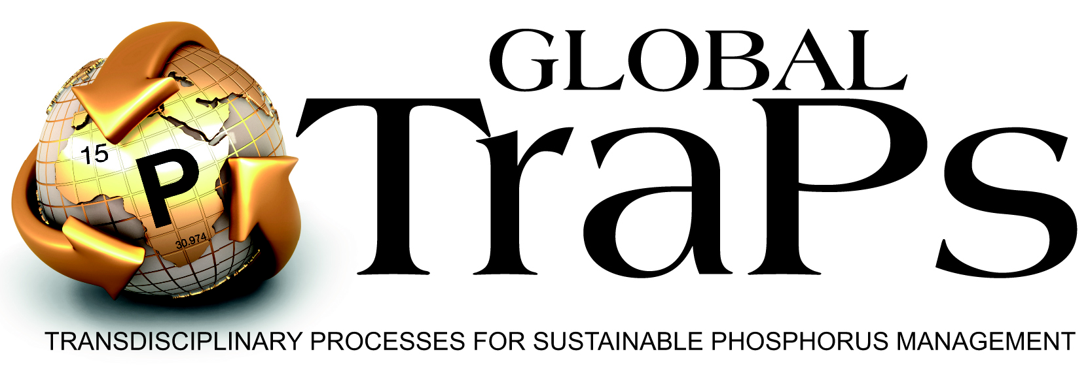

Vision for sustainable phosphorus in tomorrow’s world

Contributions of Global TraPs to the Centenary Edition of the SCOPE Newsletter

Presented at the 4th world Sustainable Phosphorus Summit, 1 - 3 Sept, Montpellier, France

Contribution 1

Efficiency – pollution -- social responsibility: Keys for sustainable phosphorus use and food security
Amit H. Roy, Roland W. Scholz and Deborah T. Hellums

Contribution 2

Transdisciplinary processes for consent-based policy options on sustainable phosphorus management
Roland W. Scholz, Tim McDaniels, Daniel Lang, Gerald Steiner and Ulli Vilsmaier

Contribution 3

The "right to know" the geopotential of phosphate resources.
Friedrich-W. Wellmer and Roland W. Scholz

P resources and their use

Efficiency – pollution -- social responsibility: Keys for sustainable phosphorus use and food security

Amit H. Roy⁽¹⁾, Roland W. Scholz⁽²⁾ & Deborah T. Hellums⁽³⁾

⁽¹⁾ Practice leader Global TraPs; IFDC, Muscle Shoals, AL, USA
⁽²⁾ Science leader Global TraPs, Fraunhofer IGB, Stuttgart, Germany and University of Zurich, CH
⁽³⁾ Practice manager Global TraPs; IFDC, Muscle Shoals, AL, USA

Producing more with less environmental impacts is a general challenge of sustainability. Against this background, efficient use of non-renewable resources such as phosphate rock (PR) used in the production of phosphorus (P) fertilizers is central to achieving sustainable agriculture. Considering that approximately 3 Mt P is consumed in food compared to the 20-22 Mt of mineral P fertilizer used in food production, annual food related P use efficiency appears to be low. This efficiency is further reduced if one considers an additional 2-3 Mt P released by anthropogenic land use [1]. Within each component of the P value chain (e.g. exploration, mining, processing, use, and recycling), opportunities for improving efficiencies exist. For example, P fertilizer production may be considered inefficient as 30-50% of the P₂O₅ equivalents in mined ore is not recovered in the finished product [2]. Globally, perennial nutrient use efficiency (PNUE), if defined as the ratio of edible crop divided by the mineral and manure fertilizer used would be a low 40% [3]. The remaining 60% would include both stored nutrients (e.g. soil, crop residues,) and nutrients lost via. runoff, erosion, etc. Thus, the sole use of efficiency parameters creates confusion. For instance, from a regional perspective, Africa has the highest PNUE for P because the soil is exploited for P, but exploitation translates into low yields. Therefore, high efficiency is not sufficient for sustainability. There is also limited knowledge about the efficiency of sewage recycling technologies. Here, the economic efficiency for recycled P relative to P fertilizers seems lower, in part because there is no consensus regarding indirect or external costs. Sustainable P management requires properly relating efficacy and efficiency on different scales. Our first vision is that this knowledge will develop in future transdisciplinary processes.

As humans have more than tripled the natural P flows, the associated losses (from runoff, erosion, overuse of P etc.) have contributed to eutrophication, hypoxia or anoxia in surface waters. There is also evidence that overuse of P affects terrestrial biodiversity [4]. Despite specific environmental issues (e.g. cadmium contamination) associated with P fertilizers, P should not be looked at as a single element, since ecosystem balance is dependent on all nutrients and other elements [5]. Our second vision is that profound environmental system knowledge is developing about critical planetary boundaries of P use and that an assessment of the global patterns of P management and its impact on the biotic earth system will be conducted.

Finally, much has been published on the scarcity of PR reserves and the 2008 price peak. Comparative analysis with other commodities, geoeconomic analysis on the dynamics of reserves, and geotechnical considerations (e.g. on offshore mining) have shown that there will be no physical scarcity in the foreseeable future [6]. PR is an abundant low cost commodity. Each person is consuming about 30 kg PR yr⁻¹ at a price of USD 6. Given the relative abundance of PR (present in 57 countries), significant long-term supply interruptions could be managed. However, PR reserves are finite and eventually there will be a peak. This reality calls for increasing the efficiency of PR and mineral P use. Furthermore, smallholder farmers are highly vulnerable to any price increase. Providing access to P fertilizers for poor farmers may be seen as a global social responsibility. Our third vision is that we will keep or establish a resilient global supply chain that provides supply security and access to P for the poor.

1. Scholz, R.W., A.H. Roy, and D.T. Hellums, Sustainable phosphorus management: a transdisciplinary challenge, in Sustainable phosphorus management: a global transdisciplinary roadmap, R.W. Scholz, et al., Editors. 2014, Springer: Berlin. p. 1-113.
2. VFRC, Global research to nourish the world. A blueprint for food security, 2012, Virtual Fertilizer Reserach Center: Washington, D.C.
3. Sattari, S.Z., et al., Residual soil phosphorus as the missing piece in the global phosphorus crisis puzzle. Proceedings of the National Academy of Sciences of the United States of America, 2012. 109(16): p. 6348-6353.
4. Venterink, H.O., Does phosphorus limitation promote species-rich plant communities? Plant and Soil, 2011. 345(1-2): p. 1-9.
5. Penuelas, J., et al., Human-induced nitrogen-phosphorus imbalances alter natural and managed ecosystems across the globe. Nature Communications, 2013. 4.
6. Scholz, R.W. and F.-W. Wellmer, Approaching a dynamic view on the availability of mineral resources: what we may learn from the case of phosphorus? Global Environmental Change, 2013. 23: p. 11-27.

Transition to Sustainable Phosphorus Use

Transdisciplinary processes for consent-based policy options on sustainable phosphorus management

Roland W. Scholz^{(1,2)}, Tim McDaniels^{(2,3)}, Daniel Lang^{(2,4)}, Ulli Vilsmaier^{(2,5),} Gerald Steiner^{(2,6)}

⁽¹⁾ Dr., Prof. em. ETH, Senior Scientist, Fraunhofer IGB, Stuttgart, Germany and University of Zurich, CH
⁽²⁾ Member of the Global TraPs Knowledge Integration Unit
⁽³⁾ Dr., Prof. of Community and Regional Planning, University of Community and Regional Planning, Vancouver, Canada
⁽⁴⁾ Dr., Prof. of Transdisciplinary Sustainable Research, Dean of Faculty of Sustainability Science, Leuphana University, Lüneburg, Germany
⁽⁵⁾ Dr., Prof. of Transdisciplinary Methods, Leuphana University, Lüneburg, Germany
⁽⁶⁾ Dr., Prof., Visiting Scholar, Harvard University, Weatherhead Center for International Affairs, Cambridge, MA, USA

The transition from the current practice of phosphorus use to an era of sustainable phosphorus management is a complex societal issue. Transdisciplinary processes (Scholz, 2011) may
- serve capacity building by relating and integrating experiential knowledge from practice with academic and technology knowledge from science,
- launch consensus building processes on the most urgent issues that have to be dealt with, including efficiency considerations and the implications of strong or weak resistance of specific stakeholder groups,

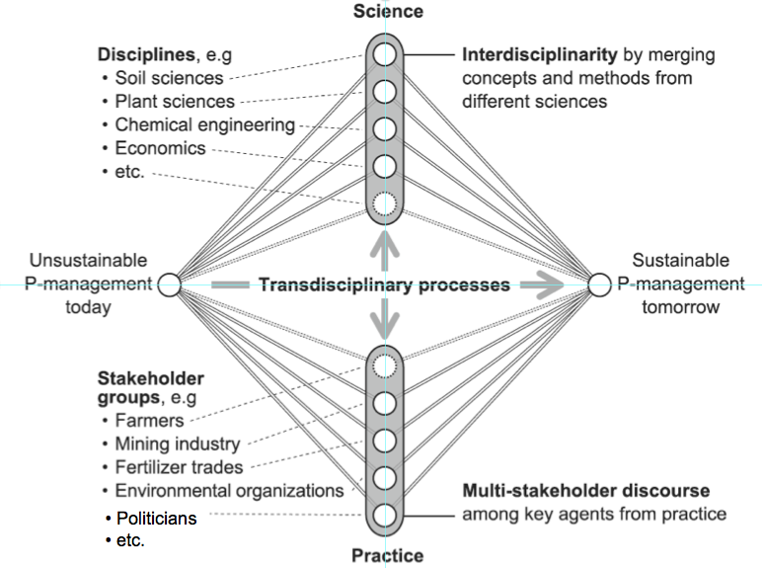
Figure 1: Transdisciplinary processes include interdisciplinary research, mitigation of interests in a multi-stakeholder discourse (Figure taken from (Scholz & Le, 2014))

- provide mitigation among affected key stakeholders, who may benefit or become disadvantaged by sustainability-oriented change (e.g., analytic mediation, multi-stakeholder discourse), and
- enable legitimization of (governmental) decision makers as they may refer to options that have been elaborated both by mutual learning among science and practice, by a multi-stakeholder discourse and by a dialogue between science and practice with decision makers.
Originating in early 2011, Global TraPs is a significant global-scale transdisciplinary project. After a joint problem definition through agreement on a guiding question among the key stakeholders, the involved scientists and stakeholders elaborated a joint system representation including a Material Flux Analysis (MFA) about the global phosphorus flows. A wide consensus that sustainable phosphorus management must address and resolve critical questions and policy options regarding accessibility to P, acceptable environmental impacts of P production, and ways to improve the low efficiency of phosphorus use (Scholz, Roy, Brand, Hellums, & Ulrich, 2014).

With respect to accessibility, we have to answer:
- How may we get reliable knowledge about the current P-reserves? What resources may become reserves under what constraints?
- How will the prices of mineral phosphorus increase if the high-grade mines are exploited?
- What technology is needed to sustainably mine resources (e.g., by offshore mining) which are currently not sustainable?
- What policy means may help that Sub-Saharan farmers will get access to the right type and right amount of phosphorus at the right time?

The environmental dimension requires answers to questions such as
- What are the planetary boundaries of anthropogenic phosphorus spread?
- What role do phosphorus emissions from agricultural use take in the eutrophication and marine dead zones?
- Is the biodiversity affected by the anthropogenic tripling of the phosphorus flows?
- Is phosphorus mining a sustainable issue or do we face unacceptable land degradation and contamination?

With respect to efficiency, the following questions are not sufficiently answered yet:
- How may we improve the efficiency of fertilizer use in agriculture?
- What losses can be identified along the supply chain? Who is losing what? How efficient is recycling of phosphorus at what part of the supply chain?
- Given that we use around 3-4 Mt P each year, but mobilize around 35 Mt mineral P along the supply chain indicates an extremely low efficiency. How can this situation be improved?

Clearly, transdisciplinary processes should support a transition to sustainable phosphorus management soon. It is clear that this is a matter of practice and thus the result of a multi-stakeholder discourse among the representatives of stakeholder groups and politicians (lower Part of Figure 1). But properly answering the complex questions above is impossible without utilizing thorough discipline-based interdisciplinary research. A transdisciplinary process efficiently organizes a process of mutual learning and co-production of knowledge from (A) problem definition, via (B) problem representation to (C) problem solving and the establishment of a future sustainable phosphorus management (Lang et al., 2012; Thompson Klein et al., 2001). Our vision is that transdisiplinary processes will essentially contribute to the transition towards a sustainable phosphorus management.

References
Lang, D. J., Wiek, A., Bergmann, M., Stauffacher, M., Martens, P., Moll, P., et al. (2012). Transdisciplinary research in sustainability science: practice, principles, and challenges. Sustainability Science, 7, 25-43.
Scholz, R. W. (2011). Environmental literacy in science and society: From knowledge to decisions. Cambridge: Cambridge University Press.
Scholz, R. W., & Le, Q. L. (2014). A novice’s guide to transdisciplinarity. In R. W. Scholz, A. H. Roy, F. S. Brand, D. T. Hellums & A. E. Ulrich (Eds.), Sustainable phosphorus management: a global transdisciplinary roadmap (pp. 116-118). Berlin: Springer.
Scholz, R. W., Roy, A. H., Brand, F. S., Hellums, D. T., & Ulrich, A. E. (Eds.). (2014). Sustainable phosphorus management: a global transdisciplinary roadmap. Berlin: Springer.
Thompson Klein, J., Grossenbacher-Mansuy, W., Häberli, R., Bill, A., Scholz, R. W., & Welti, M. (Eds.). (2001). Transdisciplinarity: Joint problem solving among science, technology, and society. An effective way for managing complexity. Basel: Birkhäuser.

Phosphate resources and their use

The "right to know" the geopotential of phosphate resources.

Friedrich-W. Wellmer ⁽¹⁾, and Roland W. Scholz ⁽²⁾

^{(1,2)} Friedrich-W. Wellmer, Prof. Dr.-Ing. Dr.h.c. mult., retired president of the Federal Institute of Geosciences and Natural Resources Hannover, Neue Sachlichkeit 32, D-30655 Hannover, Germany, fwellmer@t-online.de
^{(1,2)} Roland W. Scholz, Prof.em. ETH Dr., Science Leader Global TraPs, Fraunhofer Institute for Interface Engineering and Biotechnology, Stuttgart, Germany, and University of Zurich, Switzerland. Gartenstr. 4c, CH-8280 Kreuzlingen, Switzerland, roland.scholz@emeritus.ethz.ch

Facts:

- Over 80 % of world phosphate production is used as nutrient in fertilizers, the remainder in various industrial applications.

- While most commodities fulfill functions which can be substituted either by direct substitution or by indirect substitution via new technologies the nutrient elements are essential and irreplaceable. For potassium and nitrogen there are practically unlimited and exploitable resources (in air resp. sea water) but enriched resources for phosphate are not.

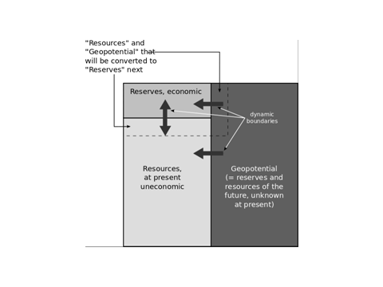
- Within the “Total Resource Box” (see Figure) three categories of resources exist: reserves (known and economic), resources in sensu strictu (known, but not economic) and geopotential (unknown so far). The categories are dynamic and so are the boundaries in-between. What are resources today can be reserves tomorrow. Consequently the ratio of reserves to production is not the lifetime of reserves but merely a snapshot of a dynamic system. The lifetime ratio can serve as early warning indicator. For phosphate the situation is very comfortable. The ratio is considerably higher than for many metals and has increased during the last 25 years, contrary to metals’ ratios that stayed within a spread of equilibrium values which satisfy mining companies’ planning scope.

Visions:

- A peak phosphorous inevitably will occur at some time in the future, but this will not be soon. The phosphorus production curve is demand driven (as a function of prices and needs), not supply driven (example for the latter: oil production in the North Sea). Nonetheless it is important to reduce waste of phosphorus, not only to conserve the non-renewable resource, but importantly because of the environmental effects of phosphorus losses. There is a considerable potential for increasing phosphorus use efficiency in the food chain.

- Wider knowledge on resources will make the general public aware that the reserve/ production ratio is not the lifetime of reserves and the true meaning of a demand driven production curve has been mostly understood, helping to avoid wrong political recommendations and actions.

- Since phosphorus is essential and unsubstitutionable it can be argued that the public is entitled to know the size of the Total Resource Box progressively (Fig.) (“right to know”). There is, however, worldwide no authority endowed to accomplish this vision. Reserve data are produced by private or state controlled mining companies. For companies, reserves are their working inventory. They, therefore, normally only gather data and estimate reserves for as many years of production as the cost associated with obtaining the data and their preference for business planning justify.
It seems appropriate to focus on the geopotential as the source of future reserves rather than on dynamically developing reserves. The vision is that there be established maybe under the auspices of the International Union of Geosciences (IUGS) or initially anchored at EuroGeoSurveys (Association of the European Geological Surveys) a solidly funded international standing committee which regularly analyzes the geopotential as done in Project 156 “Phosphate deposits of the world” of the International Geological Correlation Programme from1977 to 1984.

